1. On workstation, open two terminal windows side by side. In this section, these terminals are referred to as *left* and *right*. On each terminal window, log in to serverb as the student user.

Create a script called process101, which will generate artificial CPU load. Create the script in the /home/student/bin directory.

1. In the right window, run the **top** utility.

1. In the left terminal shell, determine the number of logical CPUs on the virtual machine. Run the process101 script in the background.

1. In the right terminal shell, observe the **top** display. Toggle between load, threads and memory. Note the process ID (PID) for **process101**. View the CPU percentage. It should hover around 10% to 15%. Ensure that **top** is showing CPU usage once you have viewed load, threads, and memory.

1. Turn off the use of bold in the display. Save this configuration for reuse when top is restarted. Confirm that the changes are saved.

1. Copy the process101 script to a new file called process102. Edit the script to create more artificial CPU load. Increase the load from fifty thousand to one hundred thousand. Start the **process102** process in the background.

1. In the right terminal shell, confirm that the process is running and using the most CPU resources. The load should be hovering between 25% and 35%.

1. The load average is still below 1. Copy process101 to a new script called process103. Increase the addition count to eight hundred thousand. Start **process103** in the background. Confirm that the load average is above 1. It may take a few minutes for the load average to change.

1. In the left terminal shell, become root. Suspend the **process101** process. List the remaining jobs. Observe that the process state for **process101** is now T.

1. Resume the **process101** process.

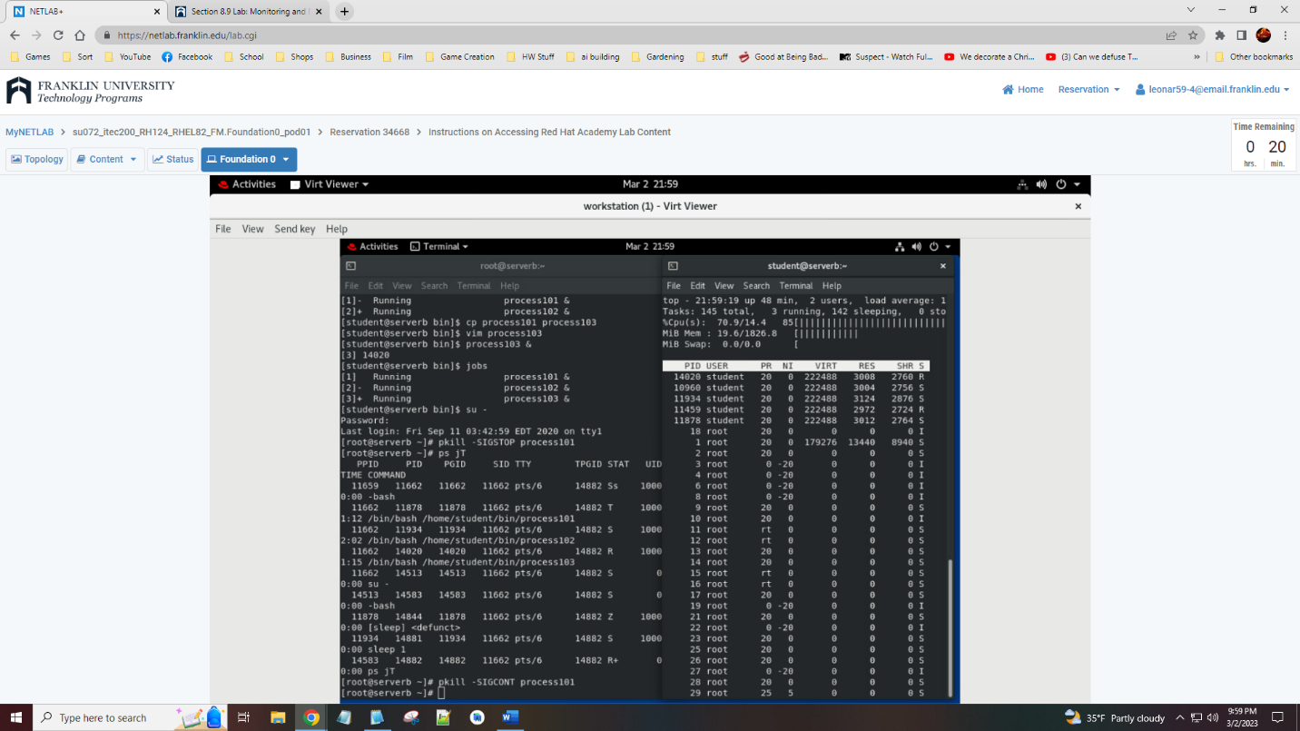

1. Terminate **process101**, **process102**, and **process103** using the command line. Confirm that the processes are no longer displayed in **top**.

1. In the left terminal shell, exit from the root user. In the right terminal shell stop the **top** command. Exit from serverb in both windows.

**Evaluation**

On workstation, run the **lab processes-review grade** script to confirm success on this exercise.

**Finish**

On workstation, run the **lab processes-review finish** script to complete the lab.

